Second build

User Instructions

How to interact with this build and what each element symbolises for the main game in the future

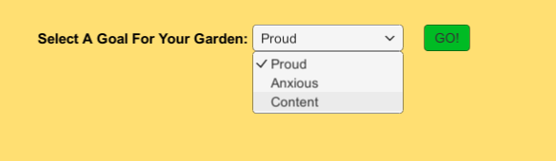

When first launching the build, the user will be met with a mood selector.

The user may select a “big mood” from this dropdown menu.

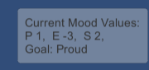

 The mood that the user selected will consist of 3 values that the player must try to get as close to as possible. After selecting a mood, the user will be taken to the main game, and the big mood’s values are displayed in this scene, as well as the gardens current three mood values that will all start at 0.

The ribbon UI at the top of the screen indicates how many Objects the user may place in their garden and the garden of player two, and the number of objects the player may remove. Later, when the user has planted the maximum of plants and or removed the same, they will be forced to end there turn.

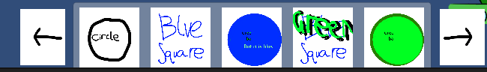

At the bottom of the screen, you will see the object selector using the navigational arrow buttons to the left and right of this selector. The user can scroll through all the objects they can spawn in the game. These will later be the plants. When one of these objects is selected, it will spawn into the scene in a random position. When in the scene, they will add their mood scores to the garden’s current mood value. Currently, all objects in the scene will affect the overall current mood value. Latter, each player will have a current mood value for their garden, and only objects in that garden well affect the gardens respective current mood vales.

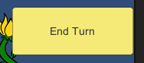

The hot seat function is operational. When the user enters the scene, they will be greeted by the player 1s turn message and be taken to the player 1s garden area, and when the user presses the end turn button, the player 2s turn message will be displayed. The camera will reposition to focus on the player 2s garden.



This arrow button allows for the active player to change the view to the opposite players garden so that they may plant flowers in that player's garden as well as their own.

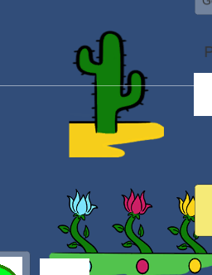

To the middle right of the scene, there is a cactus and a row of flowers. These objects are test objects for the grid. Currently, the user may left click on them to move them around the scene using the mouse. When “picked up” in this way by the user, these objects will be semi-transparent so as to allow the user to see the grid beneath them and know if the grid will allow them to be placed here. Objects when hovering over tiles on the grid interface with the tile to the top left of the test object. When hovering over a tile in the manner, the tile will change colour to indicate if this object can be placed on the tiles they are hovering over. While hovering over tiles that turn green, the user will be able to “drop” this test object into the grid, by left-clicking on the mouse again, where it will snap to the appropriate place on the grid. Once an Object has been placed on the grid, it will set all the tiles it is on top of the state Occupied and tint the sprite for that tile orange. The occupied state of the tile indicates that nothing may currently be placed on this tile.

However, if the object is hovering over tiles that turn red, this means that there is something blocking this object from being placed in this position or part of the object would off the grid if placed here, this means that if the user left-clicks the mouse again to place the object over tiles that turn red or off the grid the test object will be repositioned next to the player1s garden in the right-hand corner. Latter, this object would simply be deleted if placed inappropriately in this fashion. Later the functionality of these test objects will be combined with that of the objects spawned by the selector so as to create placeable flower objects. That can both interface and be placed on the grid and affect the garden's overall current mood value.

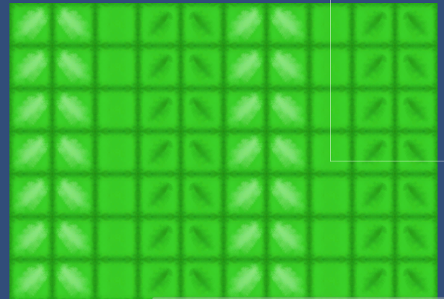

In the middle of the scene, there is a grid that consists of multiple tiles, as well as one that is in the middle of the view for player two. These grids are generated when the game starts and can be of different sizes. These grids represent player one and twos gardens. Currently, the user may click on these to set a tile to Occupied to simulate obstacles. The user may also click on a tile that is Occupied to open the tile, meaning that the sprite will return to its original version and allow for other objects to be placed on it. These tiles all have a stand-in sprite attached to them. These are chose when the grid is created to allow for different repeating patterns of tile sprites. So far, only one pattern is implemented, but this project has the full capacity to easily create different patterns.

The grid system also has ability to allow for the spawning of different grid types for possible different garden shapes if required as well as spawn different grids types on top of the first such as if a player was to place down a “pond”, then a pond grid may be spawned on top of a garden grid which would the allow for water based flowers to be placed on the pod grid but not the regular starting garden grid.

The user may press the escape button to quit.

Game Play

There currently is no official gameplay in this build. This build is merely a representation of mechanics working in the game so far, such as spawning objects from the menu, displaying the gardens mood values and placing flowers in your garden / the other player’s garden and passing the turn.

What are we waiting for?

The actual gameplay and mechanics are due to be finalised this week. When this is done, the programmers will then do their best to implement these as fast as possible so that they can be integrated into the first true playable build to be tested.

So far, all most all machines that have been fully explained to the programmers have been implemented in this build to the best degree that they can be without the supporting mechanics.

Document created by Alexander Purvis 25/02/2021